Cambrian Explosion of Cryptographic proofs

This article is based on a talk by Professor Eli Ben-Sasson, the co-founder and president of StarkWare, at the 13th Bar Ilan (BIU) Winter School on Cryptography. The BIU Winter School focused on recent advances in cryptography and blockchain technology. The lecture given by Professor Eli Ben-Sasson can be found [here](https://www.youtube.com/watch?v=4DjIeBqGBbI&list=PL8Vt-7cSFnw1gx51WHRgAtioVqAjzMS1w&index=8&t=2859s).

**What are cryptographic proofs and how are they used in blockchains ?**

Integrity was defined by C.S. Lewis as the act of “doing the right things even when no one is watching.” In the context of blockchains, cryptographic proofs are used to ensure the exact same thing - making sure that some computational processes were done right even when no one was watching. Cryptographic proofs are a set of mathematical and cryptographic operations that can be used to prove the validity of specific computations. In the late 80s and early 90s, there was a Cambrian explosion of research into cryptographic proofs. In a 1992 paper “Checking Computations in Polylogarithmic Time” by L.Babai, L. Fortnow, L.A.Lewin, and M. Szegedy, the authors accurately predicted that “a single computer can monitor the operations of a herd of supercomputers with powerful but unreliable software and untested hardware.” This means that a machine with low computing can verify if any computations made by a set of computers with powerful software were done correctly or not.

Today, whenever we send a transaction on a blockchain like Solana, Ethereum, or Cosmos, the transaction is received and executed by all the validators in the network. This becomes inefficient since, with further decentralization, the compute resources used for including every transaction in the network's history increases linearly with the number of active validators. Several projects (such as Aztec, Starknet, etc.) aim to solve this scalability problem using cryptographic proofs. The idea behind these blockchains is that they rely on a “prover” machine that includes the transaction in its network history, updates the state, and generates a cryptographic proof (which requires many resources) of execution of the set of transactions. This proof of execution is published and verified on a more reliable network such as Ethereum. In this case, the validators in the network take the role of the “single reliable PC,” and the prover is the “supercomputer with unreliable software and untested hardware.”

Even though there is a wide array of applications where cryptographic proofs can be employed to ensure privacy, security, and verifiability, their use in blockchains today is one of the most prominent and rapidly developing ones. The Cambrian explosion of cryptographic proofs is about the ever-increasing usage of these systems in blockchains. Below we can see a visualization of all the projects currently researching using such proofs in web3.

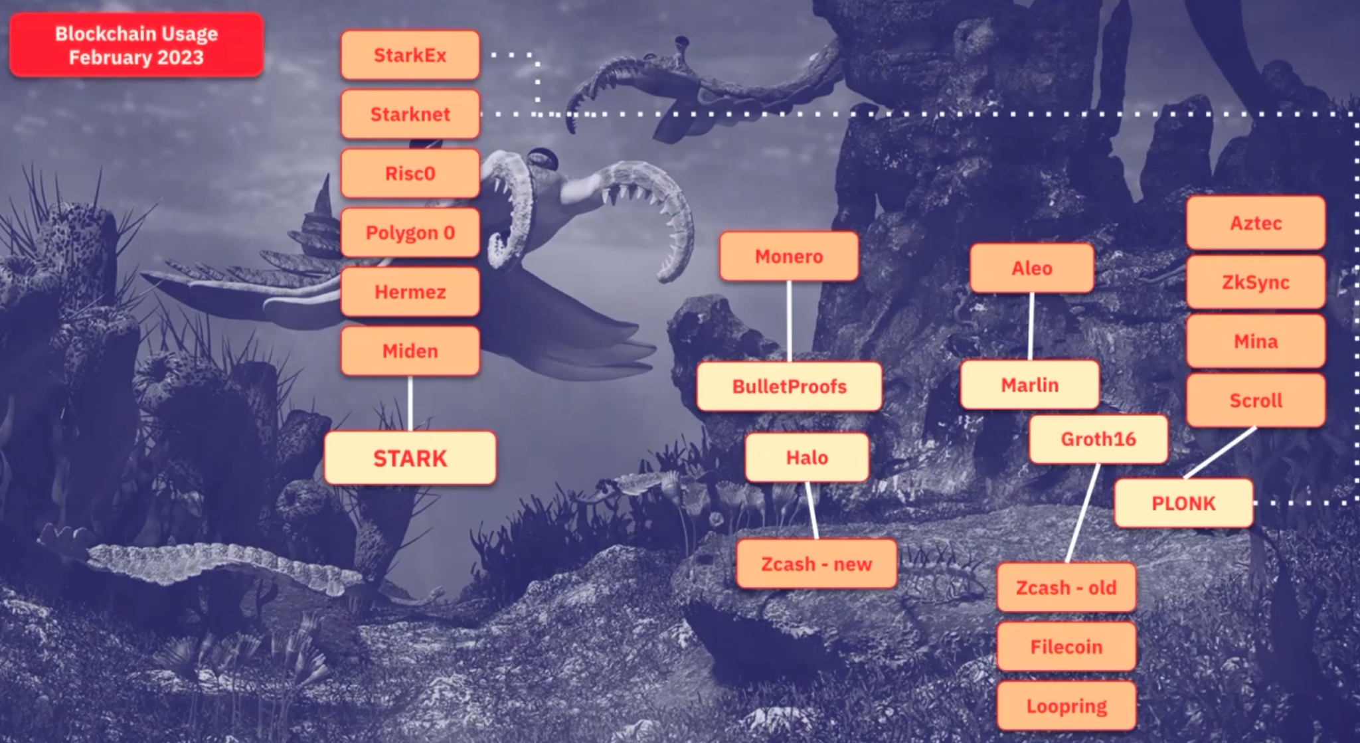

The above projects use only a tiny fraction of cryptographic proof systems that are known to us )at least in theoretical implementations).

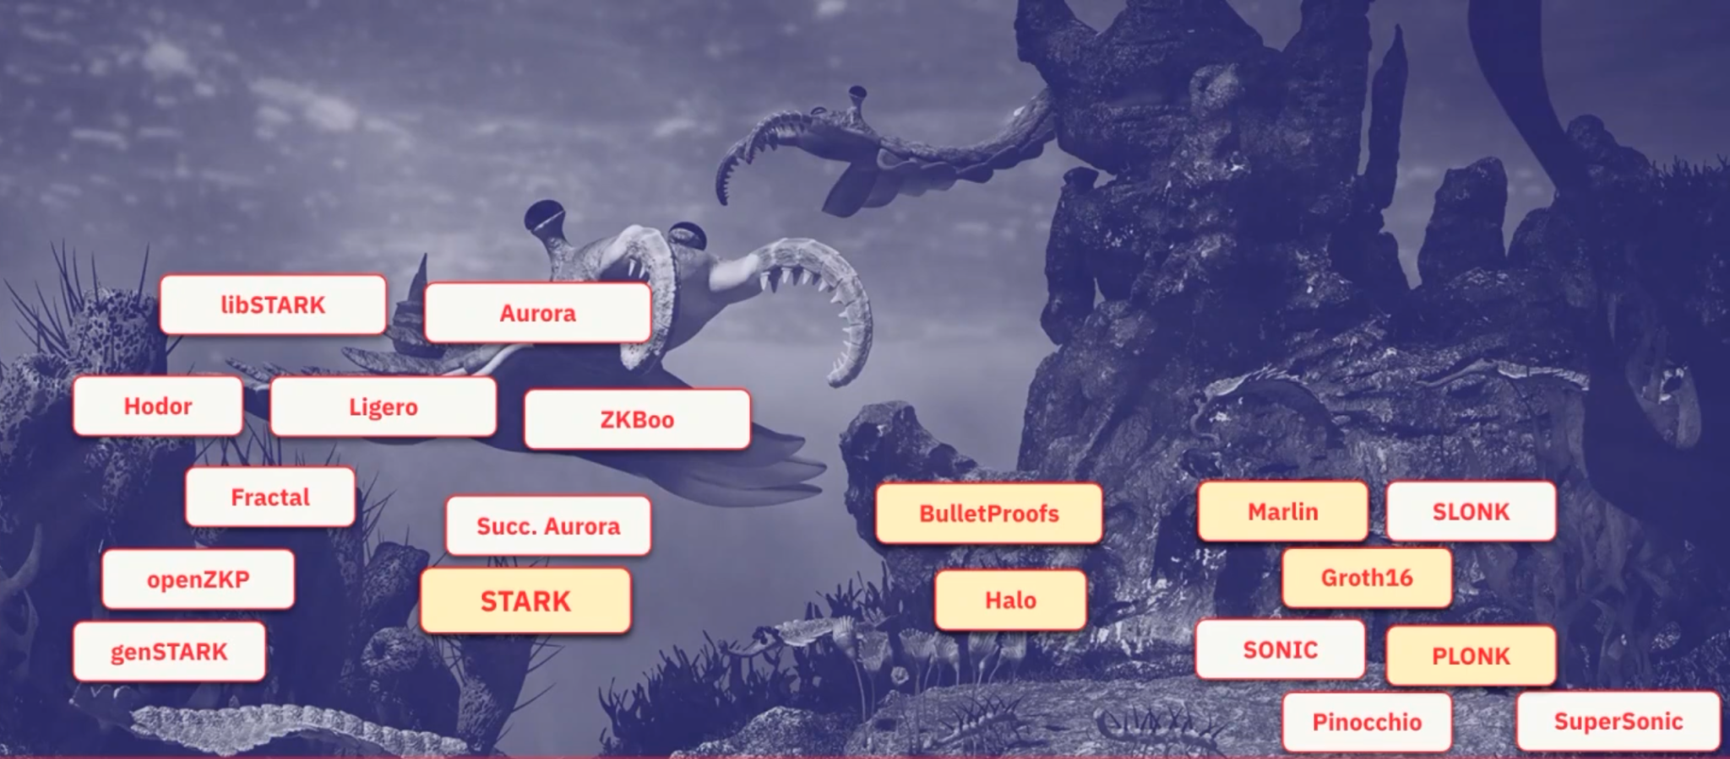

Chart showing which of the most commonly known cryptographic proof systems are used by blockchain-based projects. The ones being used by these projects are coloured in a light yellow shade.

An essential category of cryptographic proofs we often hear of is the "Zero-Knowledge" proofs (or ZKPs). With a ZKP, a party can verify that a particular statement (or computation) is true without revealing any additional information about the statement itself. As a result, on top of a significantly reduced cost of verification (inherited from the properties of cryptographic proofs), the privacy aspect comes into play. Most blockchain-based projects built on cryptographic proofs take the liberty to call their technology based on ZKPs. However, in reality, the solution they come up with is no privacy in play. In a modified visualization of the above image, we can see that most of the projects are more focused on scalability than privacy.

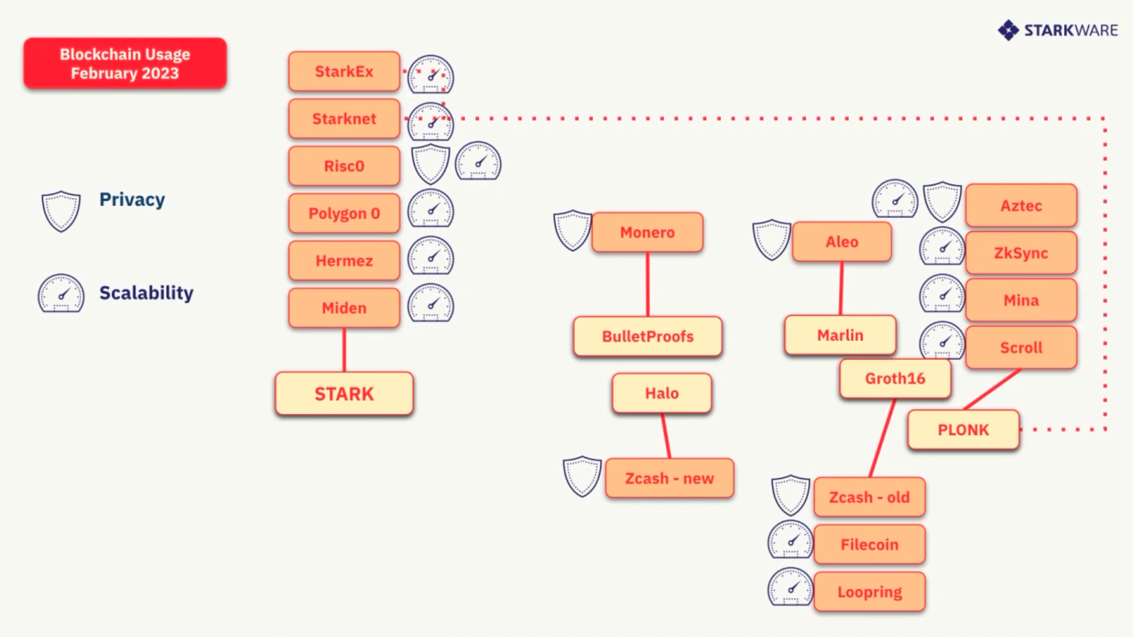

A chart displaying that only 4 of the 16 most advanced projects building with cryptographic proofs on blockchains are concerned only about privacy.

Let us now explore the differentiating factors between the proofs mentioned above. All of these use some sort of arithmetization, enforcement of low-degreeness, and certain cryptographic assumptions behind the scenes.

**What is arithmetization ?**

When looking at a set of computations that a system needs to prove, it makes sense to convert these computational problems into problems of algebra. Arithmetization in cryptographic proofs refers to the process of representing mathematical concepts and operations using arithmetic operations on finite fields.

For example, assume that Bob claims he knows a SHA2-preimage of a specific hash. If that statement is actually true, Bob should be able to generate 2 polynomials Q(x,y,t,w) and R(x) of a degree bound d. Arithmetization allows Bob to generate 4 new Polynomials, A(x), B(x), C(x), and D(x) s.t. they satisfy the equation Q(X, A(X+1), C(2*X)) = D(X) * R(X). Bob commits to the polynomials A(x), B(x), C(x), and D(x), and any verifier that wishes to cross-check Bob's claim can do so by checking if any arbitrary value of x satisfies the mentioned equation.

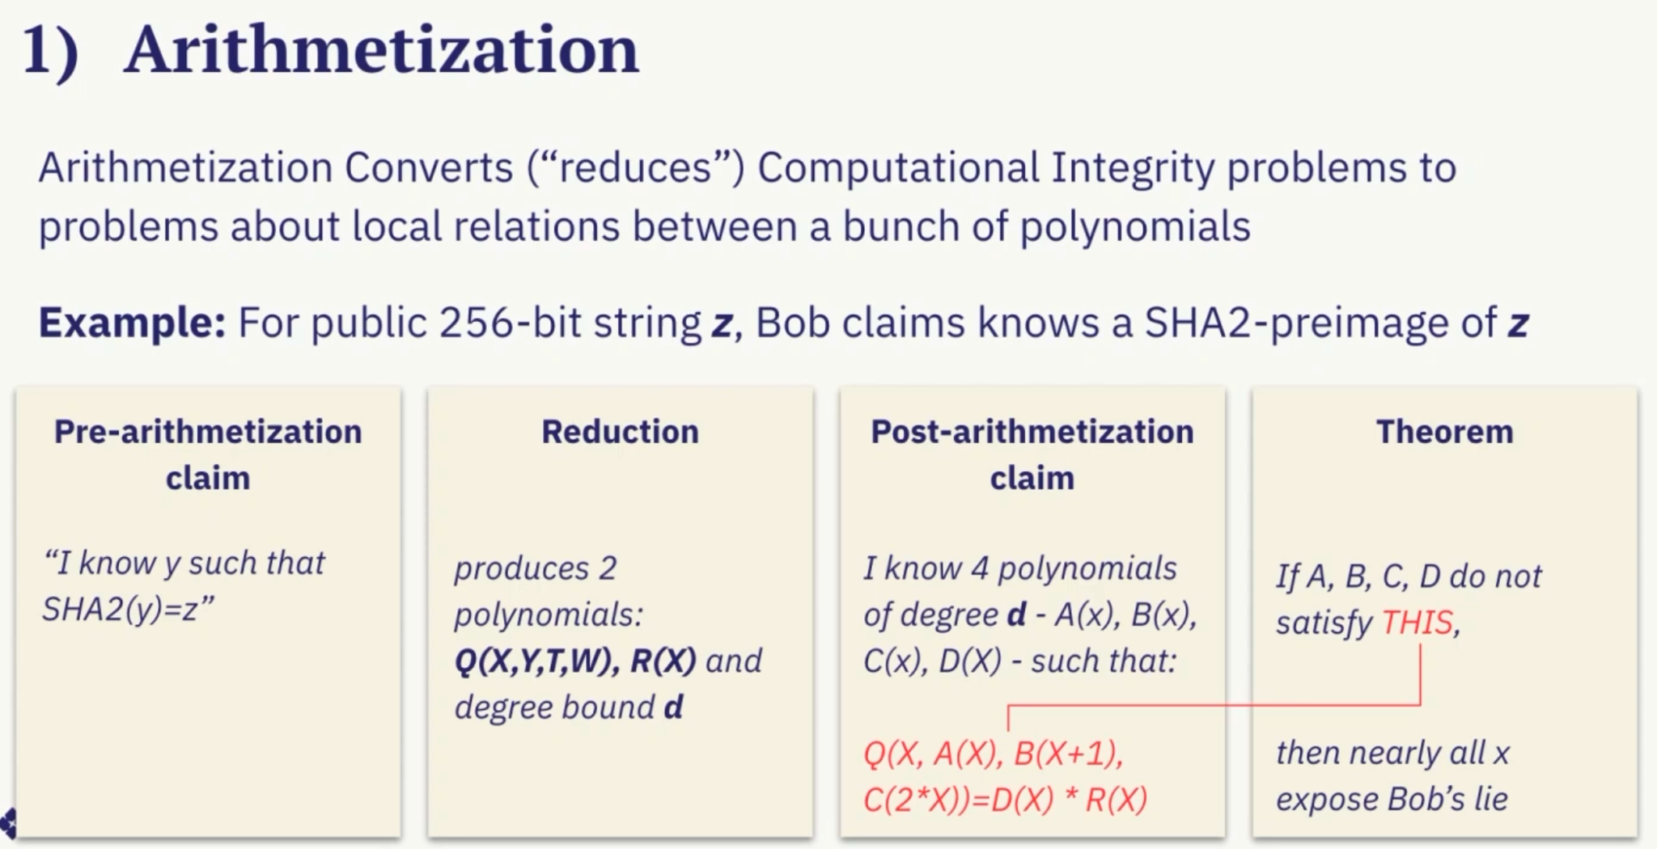

The succinctness of this proof comes from a well-known fact that for any polynomial of degree d, there are at most d zeros. Hence if we are operating in a field of integers of 128 bits, the chance of that arbitrary value x satisfying the equations completely "by chance" is d/2*128 (which would be a very small value). If this level of confidence is not enough, checking if some other value of x satisfies the above equation increases or decreases the chance of a false positive even further (the new chance of error would be (d/2**128)**2.

**Low-degreeness**

All of the cryptographic proof systems also have some sort of enforcement of low-degreeness, which is a crucial differentiating factor among them. Low-degreeness enforcement is needed for the trust system to work (as described above, the probability of erroneously accepting a false proof is related to the degree of polynomials chosen). Moreover, low-degree polynomials are used in these systems because they have some nice mathematical properties that make them more efficient.

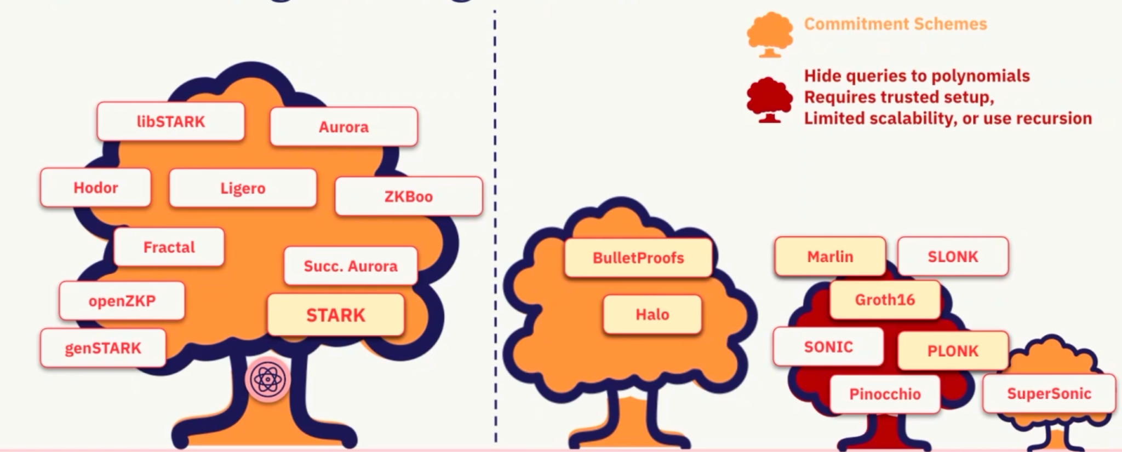

A polynomial commitment scheme is a cryptographic protocol that allows for efficient and verifiable computation on polynomials. It enables one party, called the committer, to commit to a polynomial without revealing its full details, while another party, called the verifier, can later verify the properties of the polynomial commitment. Different proof systems use different PCSs to create and verify proof. STARKs and Risc0 use the FRI commitment scheme, while Groth16 and PLONK use the KZG commitment scheme. Generally, the differentiating factors between these commitment schemes are the cost of creating the proof, the size of the proof, and the cost of verifying the proof.

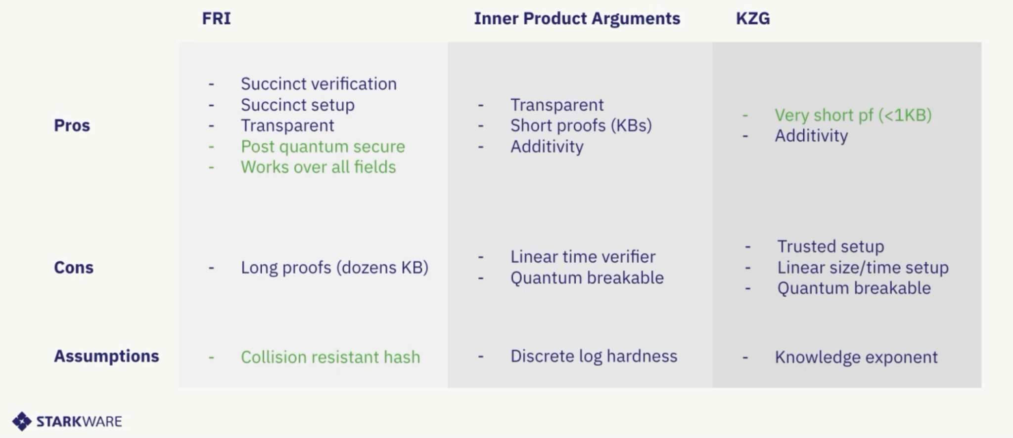

The STARK proof system uses the "FRI" (Fast Reed-Solomon Interactive Oracle Proof) protocol to enforce low-degree polynomials. Under this system, the prover iteratively interacts with the verifier and commits to new polynomials such that the degree of each new polynomial is half the previous one. PLONK system uses polynomial commitments based on elliptic curve mathematics (for example, KZG). However, such systems may require a trusted setup. A trusted setup is an arrangement under which specific secret parameters are to be generated. However, the pre-image of these parameters should remain private (in case it is not, then the whole proof system breaks down, and the generation of false proof becomes possible). Generally, special trusted setup "ceremonies" are organized in which multiple parties privately create random elements combined to get the final parameters. If even a single party from these successfully destroys the random elements it submitted, the setup can be considered secure.

**Cryptographic Assumptions**

Any other cryptographic assumptions these systems use are also essential to keep track of. For instance, some of these uses rely on elliptic curve mathematics (e.g., BulletProofs and Halos) or "knowledge of exponent" (e.g., Groth16, PLONK, etc.), which are quantum-computer breakable. On the other hand, others use collision-resistant hashes which are quantum-computer resistant (e.g., STARKs, ZKBoo, etc.).

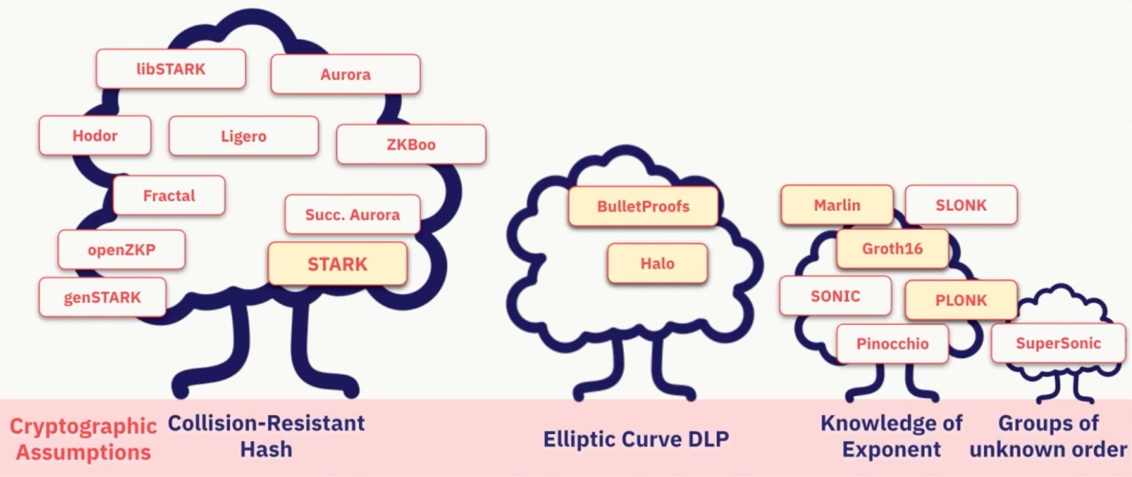

As we can see from the above discussion, a vast array of cryptographic proofs can be used to achieve scalability and transparency (or privacy). While some proofs might be very convenient in use for short proofs (such as Groth16), some other systems are better off in large computations (such as STARKs - in the opinion of Prof.Eli). However, as the ecosystem matures, we will see one type of cryptographic proof used extensively. "May the best system win !"